Task 01: Creating the Git Repository using SSH
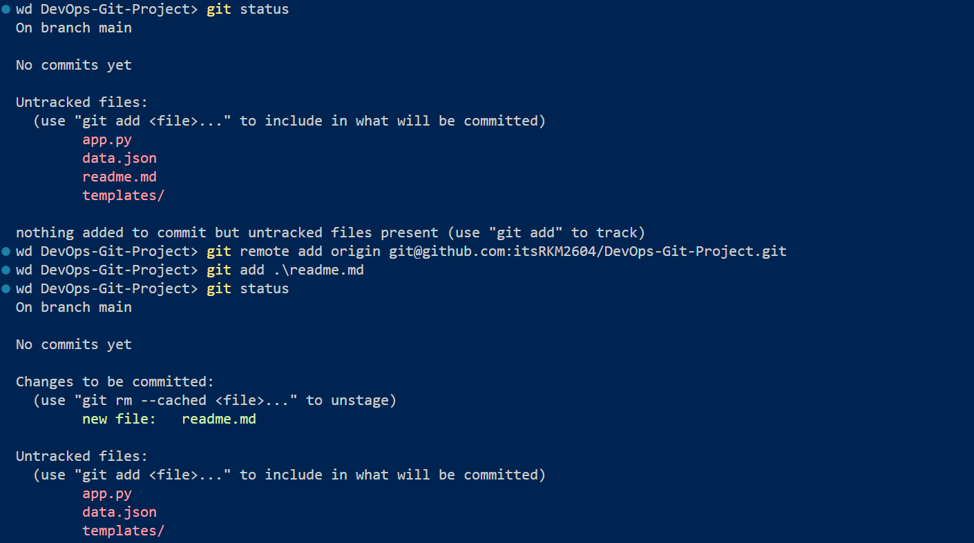
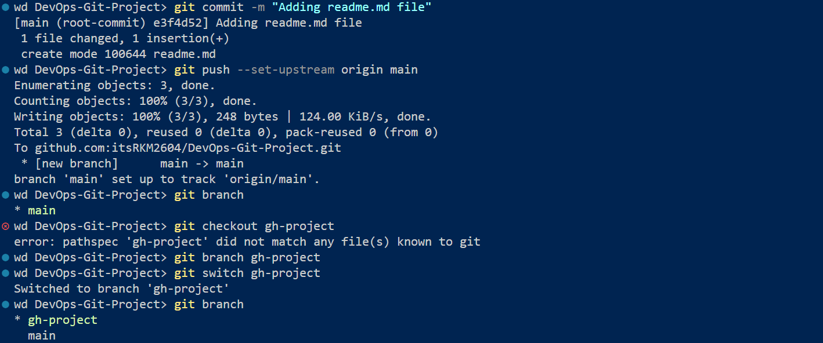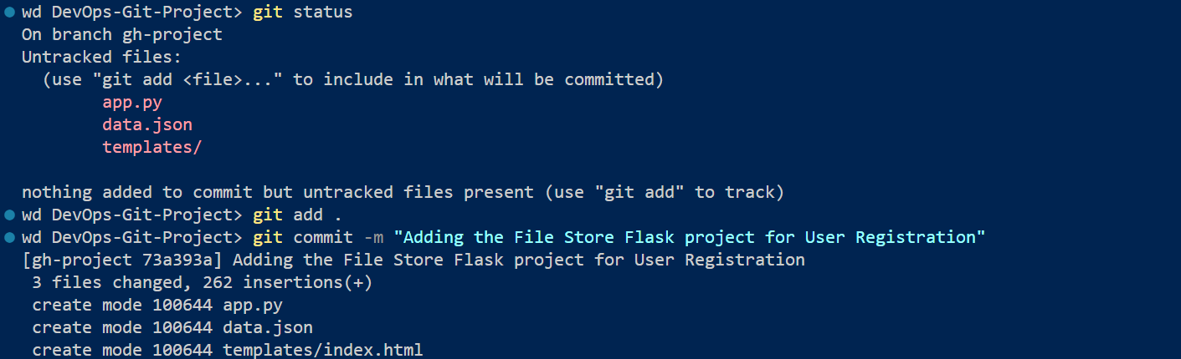
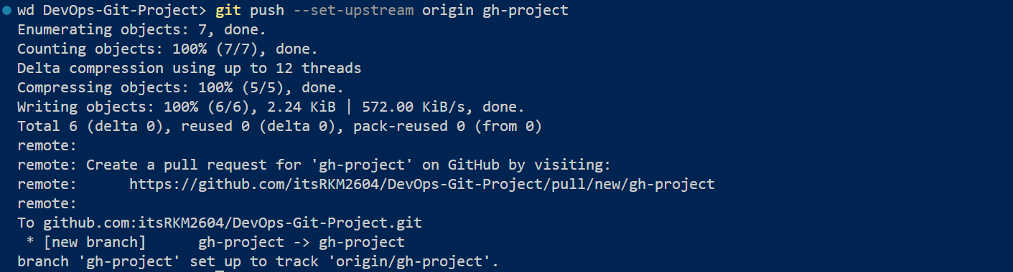
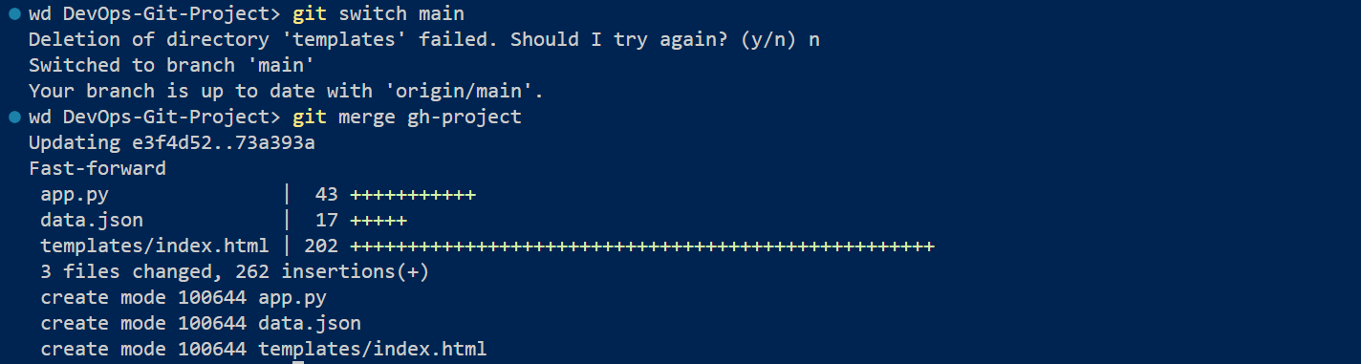

Task 02: Creating New Branch
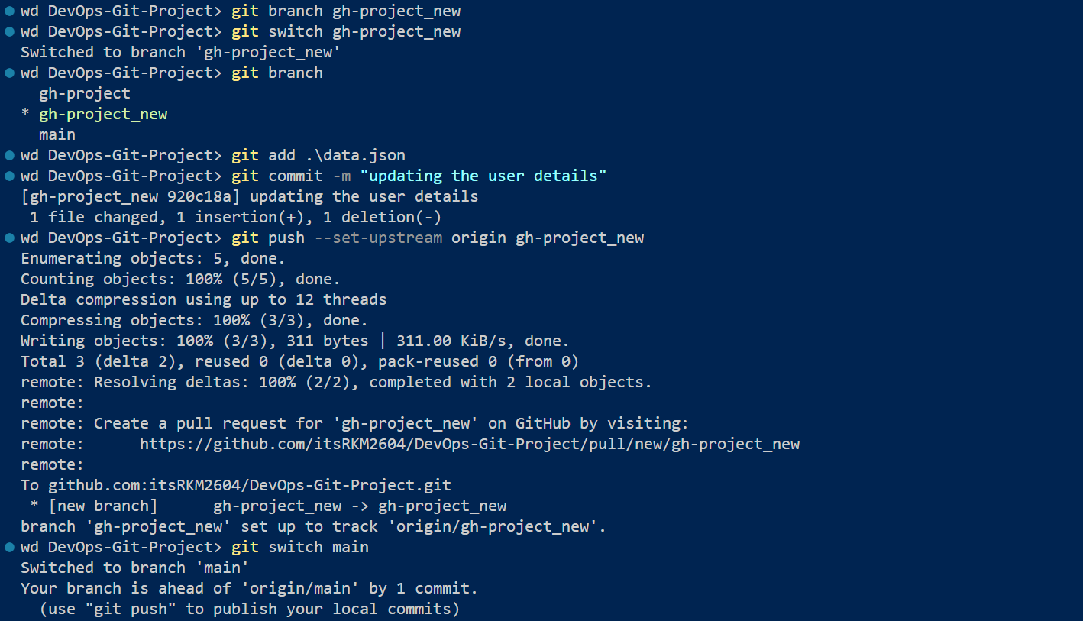
Handling Merge conflict from “gh-project_new” branch
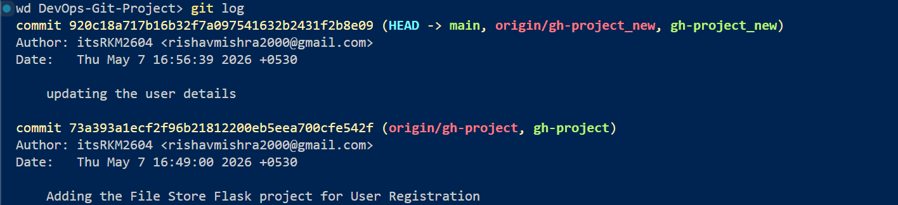
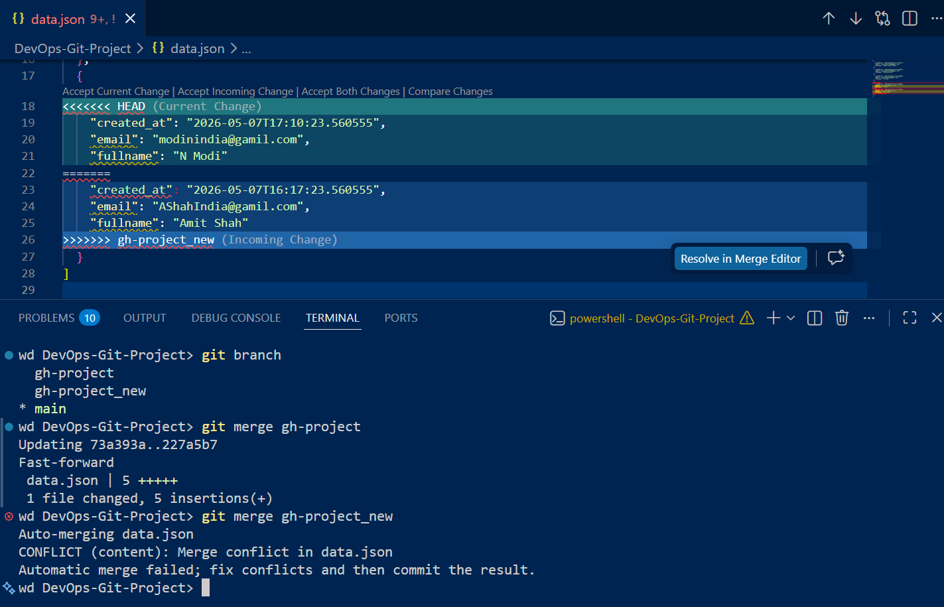

Accepted Incoming Changes
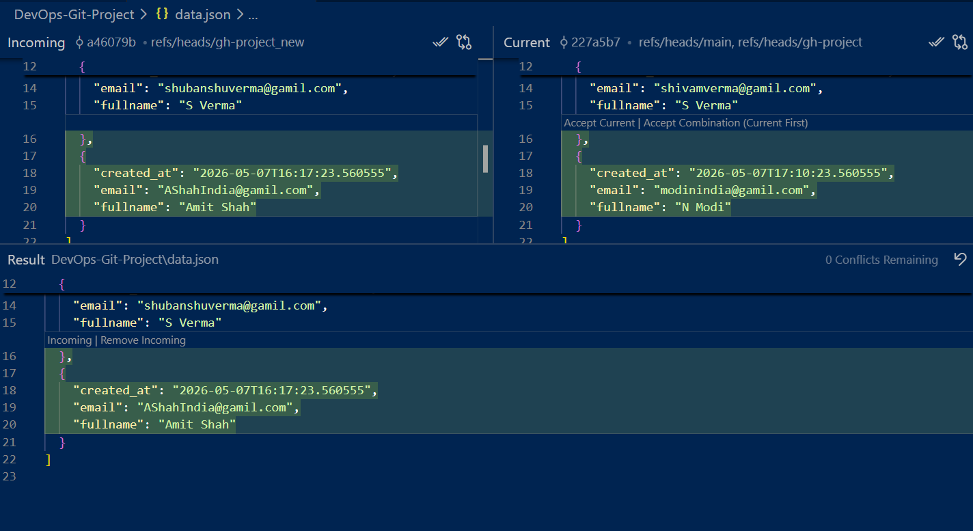
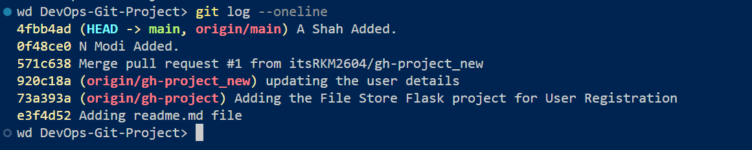
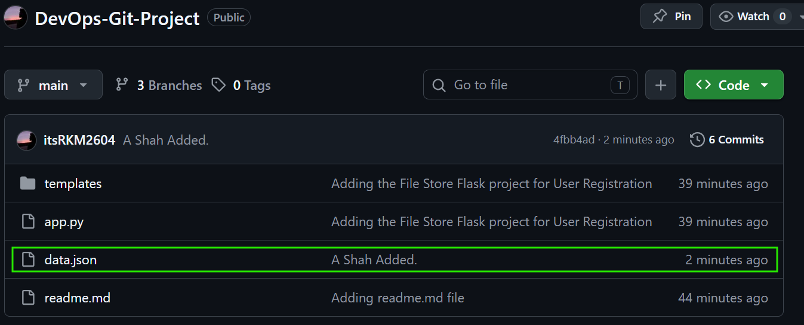

Task 03: Creating “master_1” & “master_2” branch for todo item project
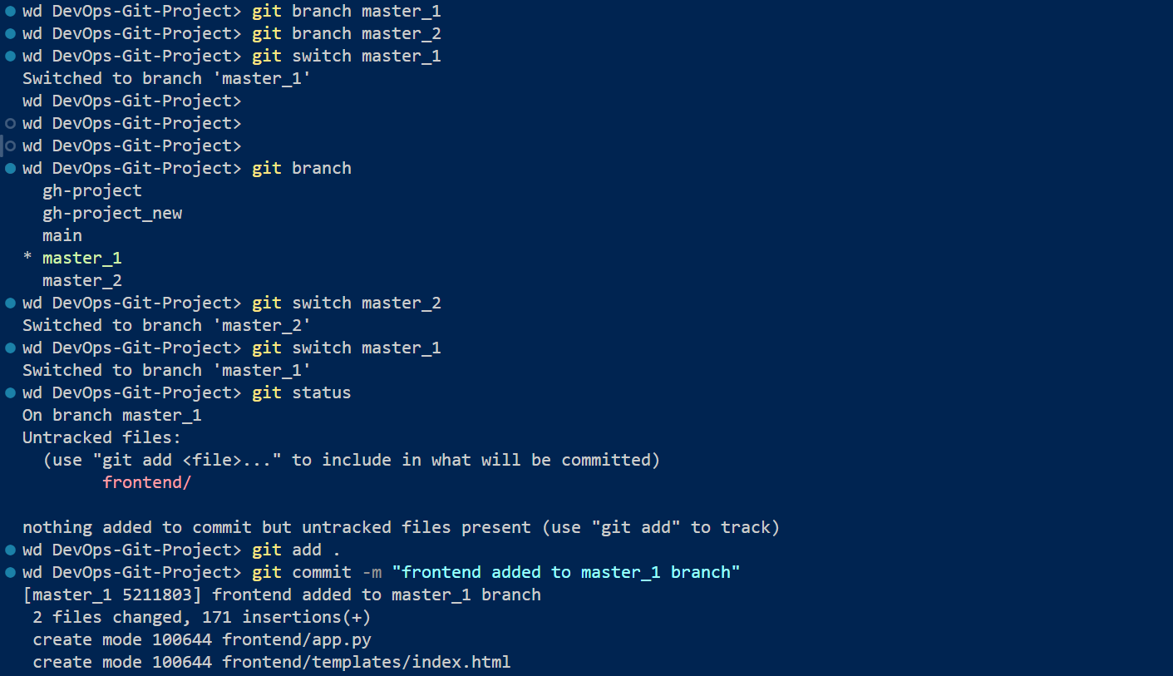
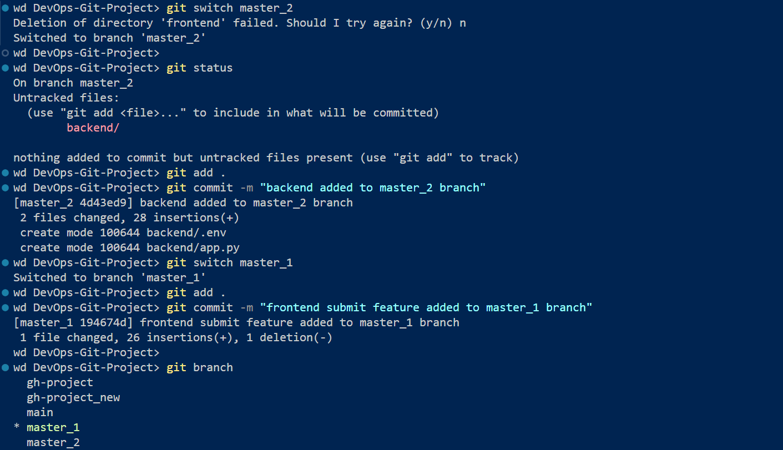

2 branchs has been created (master_1 & master_2)
master_1 – frontend (separate commits)
master_2 – backend (separate commits)
merged both master_1 & master 2 to main branch

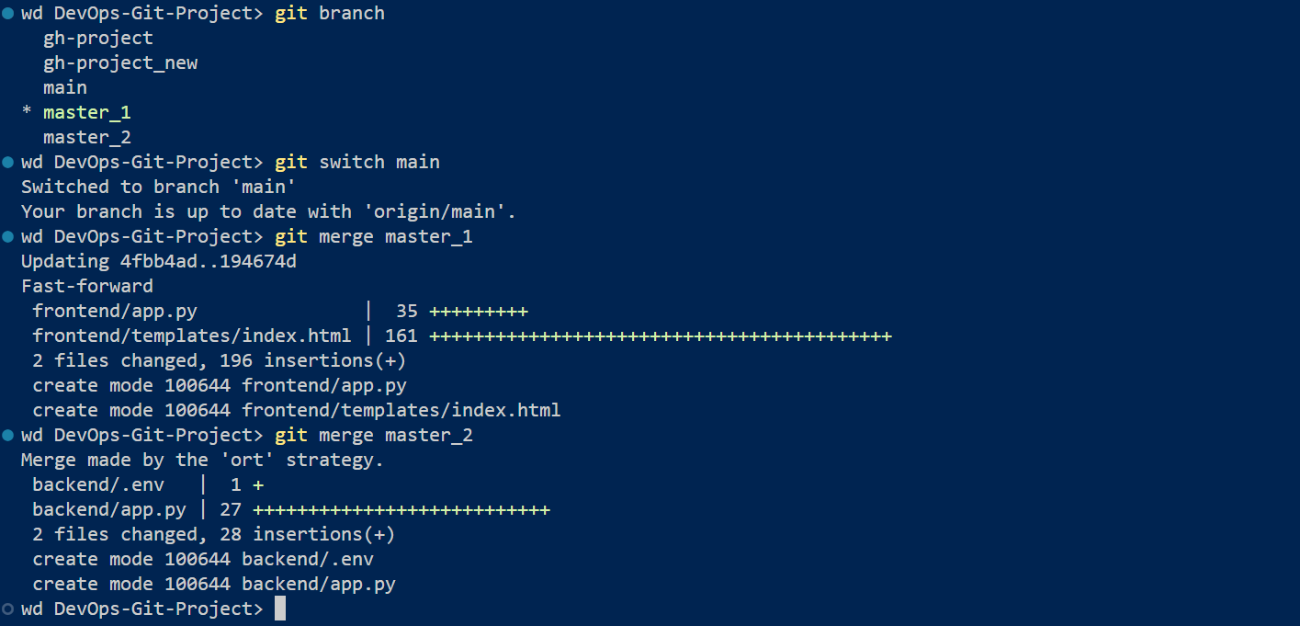
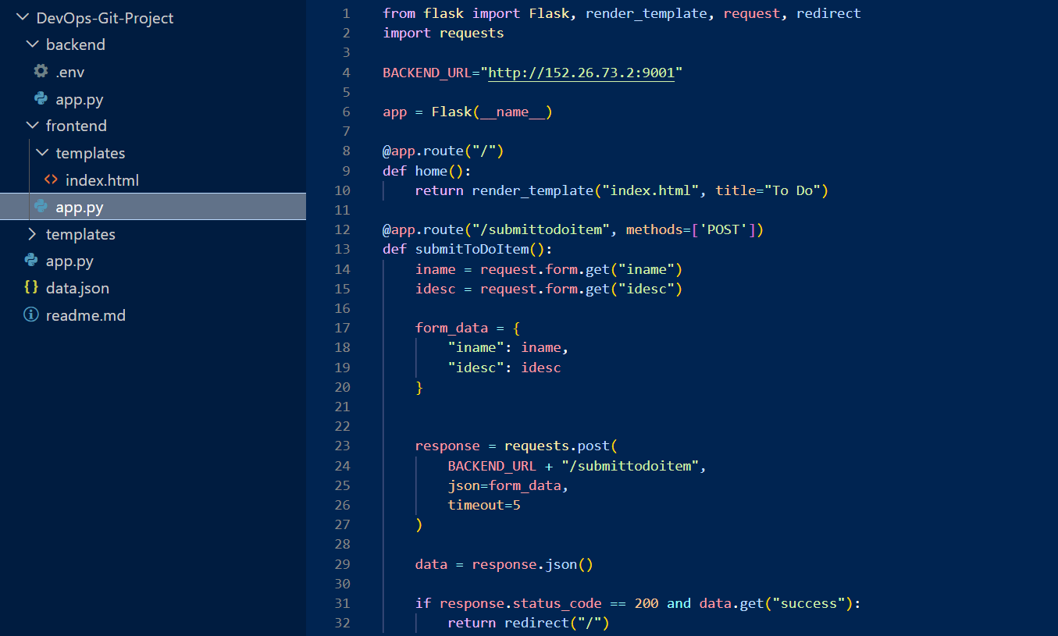
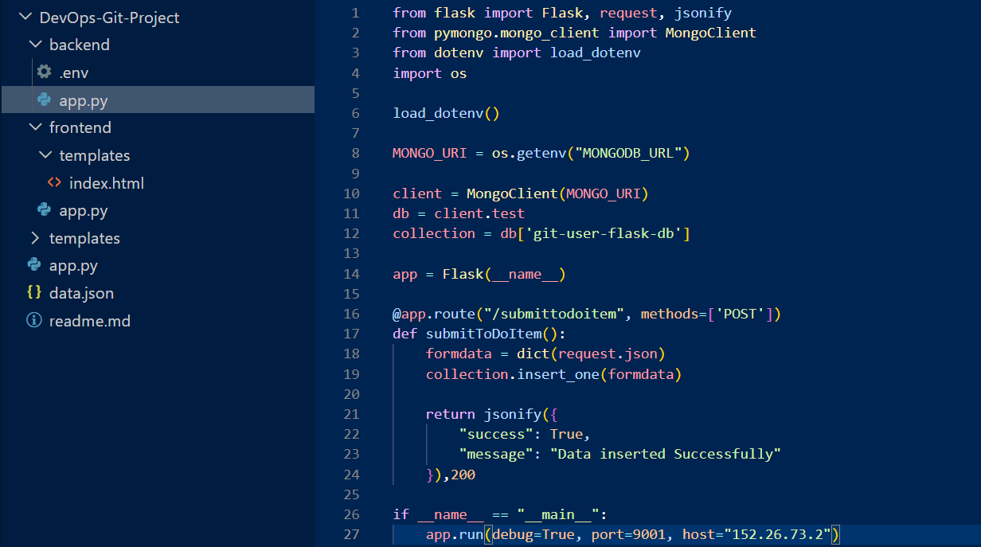
Task 04: Adding new features to todo item project
Item ID, UUID & Hash code field added one by one
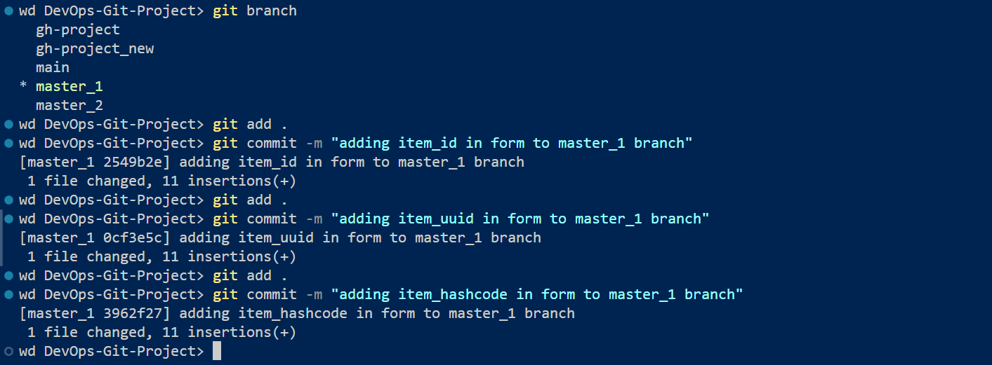
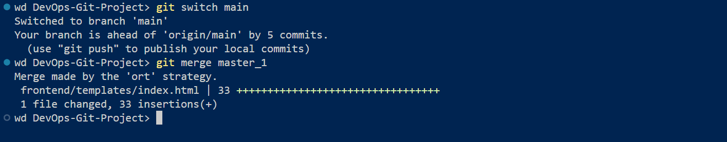
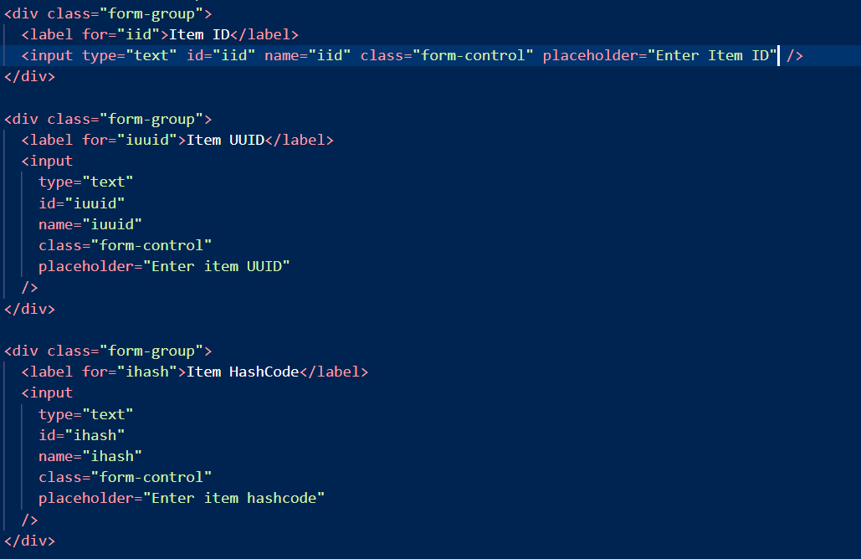

Git log showing 3 separate commit done for 3 features
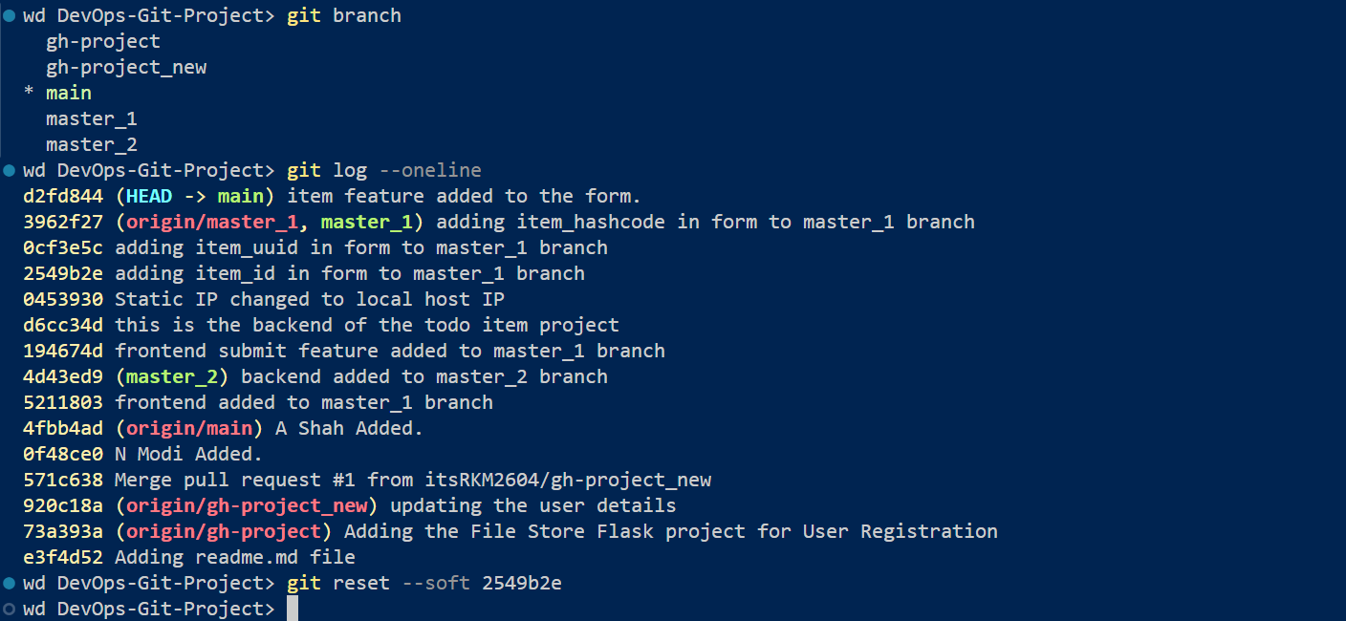
Soft reset got UUID & Hash code feature on mail branch
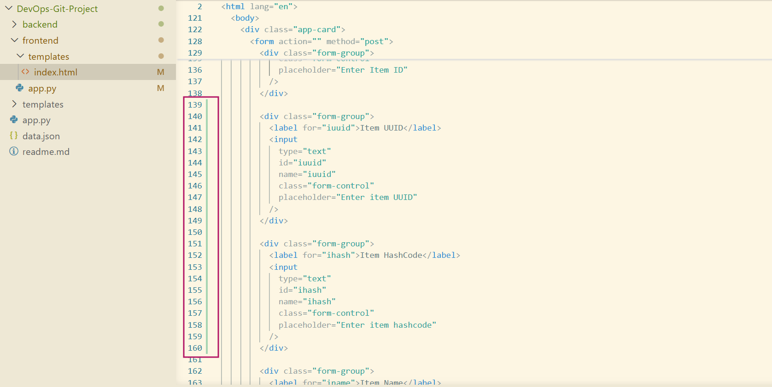
adding upstaged commits on mail branch
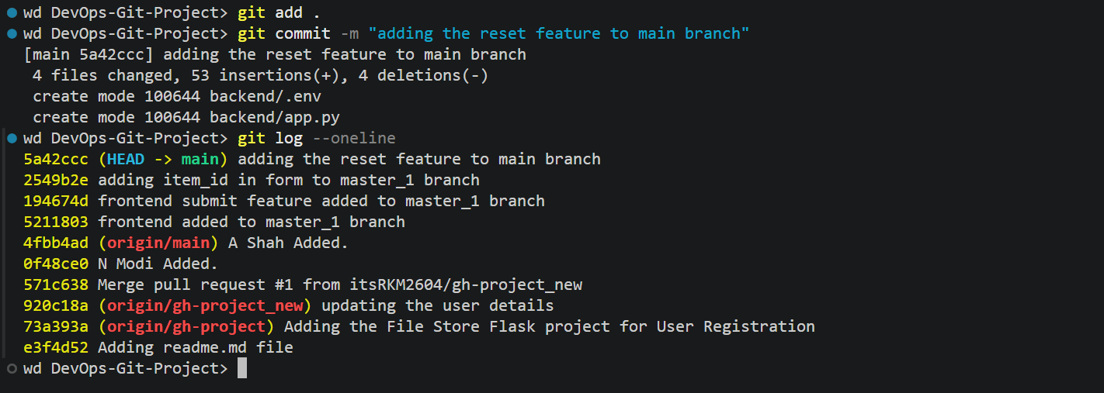

Rebase
